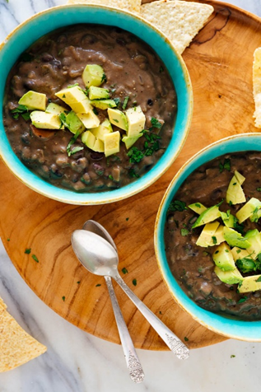Black Bean Soup

|  |
| --- |
| Ingredients With Measurements  * 2 tablespoon extra-virgin olive oil * 2 medium yellow onions, chopped * 3 celery ribs, finely chopped * 1 large carrot, peeled and sliced into thin rounds * 6 garlic cloves, pressed or minced * 4 ½ teaspoon ground cumin * ½ teaspoon red pepper flakes * 4 cans (15 ounces each) black beans, rinsed and drained * 4 cups (32 ounces) low-sodium vegetable broth * ¼ cup chopped fresh cilantro * 2 tablespoon fresh lime juice |

|  |
| --- |
| Recipe Heat the olive oil in a large Dutch oven or soup pot over medium heat until shimmering. Add the onions, celery and carrot and a light sprinkle of salt. Cook, stirring occasionally, until the vegetable are soft, about 10 to 15 minutes.  Stir in the garlic, cumin and red pepper flakes and cook until fragrant, about 30 seconds. Pour in the beans and broth and bring to a simmer over medium-high heat. Cook, reducing heat as necessary to maintain a gentle simmer, until the broth is flavorful and the beans are very tender, about 30 minutes.  Transfer about 4 cups of the soup to a stand blender, securely fasten the lid, and blend until smooth. Or, use an immersion blender to blend a portion of the soup.  Return the pureed soup to the pot, stir in the cilantro, lime juice and salt and pepper, to taste. Serve. |

|  |  |  |  |  |  |  |  |  |  |  |  |
| --- | --- | --- | --- | --- | --- | --- | --- | --- | --- | --- | --- |
| |  |  |  | | --- | --- | --- | | Extra Virgin Olive Oil | Onion | Celery | | Carrots | Garlic | Ground Cumin | | Red Pepper Flakes | Canned Black Beans | Low-Sodium Vegetable Broth | | Cilantro | Lime Juice |  Ingredients Without Measurements |